# ACTIVITY #1:

// This program outputs the message "Hello World"

public class ActivityOne {

public static void main (String args [])

{

System.out.println ("Hello World");

}

}

## Changing class name:

Error: no main classes found

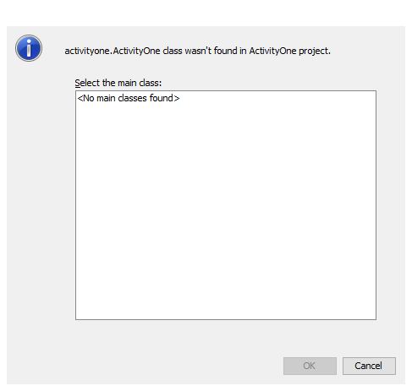

Compile time error!!

## Removing Opening brace:

1. Error: ‘{‘ expected

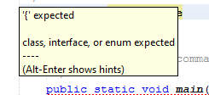

## Removing the closing brace:

1. Error: reached end of file while parsing

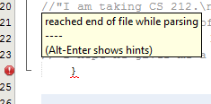

## Using ‘s’ instead of ‘S’:

1. Error: pakage system does not exist

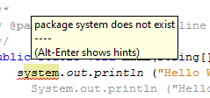

## Ignoring ‘;’:\

Error: ';' expected

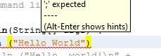

## SNAPSHOT:

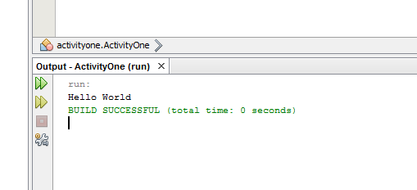

# ACTIVITY #2:

public class ActivityTwo {

/**

* @param args the command line arguments

*/

public static void main(String[] args) {

System.out.println ("Hello, world!\n" +

"I am taking CS 212.\n" +

"I hope it is a lot of fun!\n\n" +

"My teacher’s name is Hamayun / Anis.\n\n" +

"I hope he gives me a grade of 4.0!");

}

}

## SNAPSHOT:

# ACTIVITY #3:

public class ActivityThree {

public static void main(String[] args) {

System.out.println("Properly indented programs");

System.out.println("look ever so much better!");

System.out.println("please fix me");

System.out.println("and make me beautiful again");

}

}

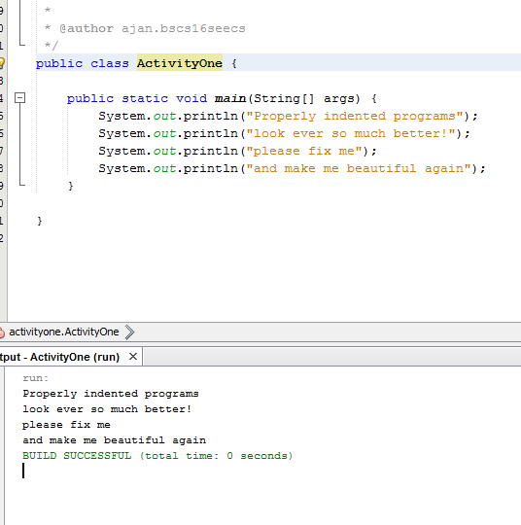

# ACTIVITY #4:

public class ActivityFour {

public static void main(String[] args) {

System.out.println("Testing, testing,");

System.out.println("one two three.");

System.out.println();

System.out.println("How much output");

System.out.println();

System.out.println("will there be?");

}

}

There are six lines including the empty ones which equals to the number of println statements.

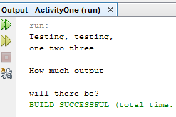

# ACTIVITY #5:

### '{' expected:

After ActivityFive ‘{‘ is missing

### invalid method declaration; return type required:

“void” keyword missing

### String not enclosed in “”:

In the first println statement Hello world is not enclosed in as “”

### incompatible types: String cannot be converted to Boolean:

‘?’ is outside “” 0000

### wrong function Println is used instead of println

### ';' expected:

In third println statement.

### package system does not exist

System instead of system

### cannot find symbol: symbol: method pritnln(String)

spelling error

### ')' expected:

### cannot find symbol: symbol: method println(String

inner class out is missing

### ‘{‘ istead of closing brace00000000000000

## CORRECT CODE:

public class ActivityFive {

public static void main(String[] args) {

System.out.println("Hello world");

System.out.println("Do you like this program?");

System.out.println();

System.out.println("I wrote it myself.");

}

}

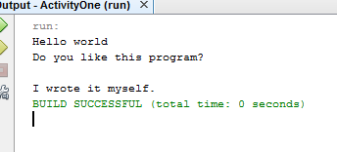

# ACTIVITY #6

## Naming your file incorrectly, then compiling.

No apparent error!

## Forgetting a keyword such as void or class

invalid method declaration; return type required

## Forgetting a quotation mark "

unclosed string literal

## Forgetting a parenthesis ( or )

')' expected

Or

not a statement

';' expected

## Forgetting a dot .

cannot find symbol

symbol: method outprintln(String)

location: class System

## Using too many or too few braces { or }

missing method body, or declare abstract

';' expected

# ACTIVITY #7:

public class ActivitySeven {

public static void main(String[] args) {

System.out.println("A \"quoted\" String is\n" +

"'much' better if you learn\n" +

"the rules of \"escape sequences.\"\n" +

"\nAlso, \"\" represents an empty String.\n" +

"Don't forget: use \\\" instead of \" !\n" +

"\'\' is not the same as \"");

}

}

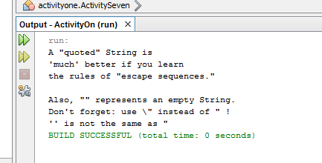

# ACTIVITY #8:

public class ActivityEight {

public static void main(String[] args) {

System.out.println(" \\/\n" +

" \\\\//\n" +

"\\\\\\///\n" +

"///\\\\\\\n" +

" //\\\\\n" +

" /\\");

}

}

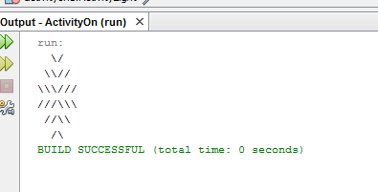

# ACTIVITY #9:

public class ActivityOne{

public static void main (String[] args){

int result = 1 + 2; // result is now 3

System.out.println(result);

result -= 1; // result is now 2

System.out.println(result);

result *= 2; // result is now 4

System.out.println(result);

result /= 2; // result is now 2

System.out.println(result);

result += 8; // result is now 10

result %= 7; // result is now 3

System.out.println(result);

}

}

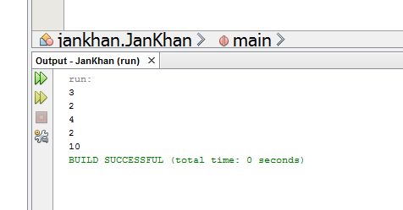

# Task 1:

public static void main (String[] args){

Scanner scanner = new Scanner(System.in);

System.out.print("What is your year?\n1-Freshmen\n2-Sophomore\n3-Junior\n4-Senior\n");

String year= scanner.next();

System.out.print("Number of courses:");

int courses= scanner.nextInt();

System.out.print("GPA:");

double gpa= scanner.nextDouble();

System.out.print("\n\n\nOUTPUT:\n\nYear: " + year + "\nCourse: " + courses + "\nGPA: "+gpa+"\n\n");

}

}

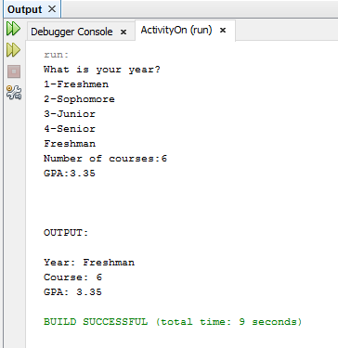

# Task 2:

# import java.util.Scanner;

public class JanKhan {

public static void main(String[] args) {

Scanner reader = new Scanner(System.in);

System.out.print("Enter the number:");

int num = reader.nextInt();

System.out.print(num);

int temp=num;

int divider= 10000;

temp = (num/(divider))%10;

System.out.print(" " + temp);

for(int i=0; i<5 ;i++){

temp = (num/(divider))%10;

System.out.print(" " + temp);

divider = divider/10;

}

}

}

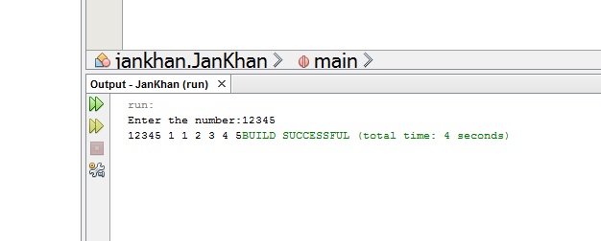

# TASK 3:

public static void main(String[] args) {

Scanner reader = new Scanner(System.in);

System.out.print("Enter x:");

double x = reader.nextDouble();

double ans = (12.3)*Math.pow(x, 4) - (9.1)*Math.pow(x, 3) + (19.3)*Math.pow(x, 2) +(12.3)*x+34.2;

System.out.print("The answer is: " + ans);

}

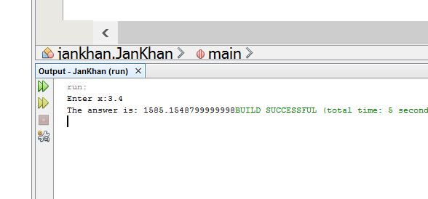

# TASK 4

public static void main(String[] args) {

Scanner reader = new Scanner(System.in);

System.out.println("Enter time :");

double t= reader.nextDouble();

System.out.println("Enter position:");

double s0= reader.nextDouble();

System.out.println("Enter velocity:");

double v0= reader.nextDouble();

System.out.println("Enter acceleration");

double a= reader.nextDouble();

double distance = s0+v0*t+ 0.5*a*Math.pow(t, 2);

System.out.println(distance);

}

